The Classic Policar Grand Prix of the Wirral 2024

Wirral Scalextric Club held their 2nd Annual Policar event for 2024l held on the 6th April.

The rules are simple, bring along your Policar Classic F1 car and compete. Basic out the box with just a few basic changes usually the wheels and tyres and possibles changing of the braids.

With an open entry advertised by word of mouth or in the slotcar forums we received 16 entries from around the country and club members.

The format is simply, everyone competes in heats the results of which sets the grid for the step-up system to achieve a final four for the final race. Top two racers progress up the next step-up ladder to the next race.

Step up 1 Race
The first step up involved Paul Cash (yes him from Pendle up far north and a great model maker too) along with Mike Ward (all the way from Bristol), Dave Mitcham (member of the club and very talented slot car builder) and finally Andi Rowlands (designer of the Policar gearbox from Deep Southwest London way). Andy led from the off with confidence gained after winning a heat in the morning this was a close fight, but Andi held the lead for the 70laps chased hard by Dave who was battling with Mike for the step-up spot of second position. Paul Cash took up the rear but could not match the pace of the other runners.

Step-up 2 Race
This included Andi and Dave who now stepped up for this race with Paul Cooper (club member) along with Steve Dulson (club member who had a bad race in the heats). This race was a straight forward race with Steve’s pace showing as he won by 4 laps and chased by Paul who knew all he had to do was stay on the track at a reasonable pace, chased very hard by Andi who just could not find the pace on the outside lane followed by Dave struggling with pace on the other outside lane as well.

Step- up 3 Race
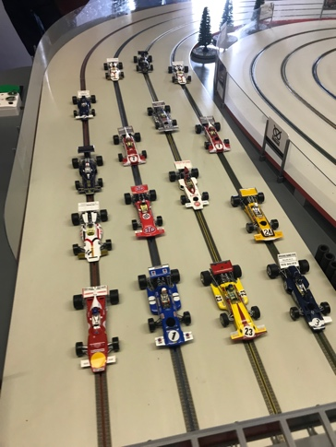
Paul and Steve stepping up to face Mark Brandwood (coming all the way from Lancashire whose local clubs are Hawthorne and the East Lancs club) and Dave Maddock (everyone knows Dave, living on the Welsh coast and racing in Denbigh and other locations). This again was a Steve show as he sped away to an 80lap victory followed by Mark for the next step-up place leaving Dave who struggled to make up time from an early off and Paul who couldn’t keep the pace in this race.

Step Up 4 Race
So super Steve stepping up to his third race now along with Mark facing Mr Peter Wright (club member and organiser) and Roger Moore (not that one, but the fast racer from Small World Slot Car Club and the Hawthorne Club). This race was full of excitement with Pete leading from the lights chased hard by Roger and Mark, on lap 25 Pete tripped over a back marker and this gave Roger the lead closely followed by Mark, with a crash on lap 51 changed the order with Pete leading until the chequered flag after 85 laps, with Roger taking the next step- up place.

Step Up 5
Pete and Roger now stepping up to face the Jeff Norton (East Lancs Club travelling all the way down from the North) and Dietrich Kruger (club member at the Wirral who is here due to the kind permission of his mother inlaw).
Jeff started from pole, Pete got off to a hot start and led until lap 15, then tangling with Dietrich and giving the lead to Jeff who kept it until the end of the 90laps with Pete having a blistering pace to finish second taking the step-up place.

Step Up 6
Waiting for Pete and Jeff for this semi final were Paul Taylor (C.E.O. Of the Club and designer and fabricator of all 3D slot car stuff) next to Peter Crane (no need for introductions here a Policar super racer from the early days). This race had pace and action a plenty with Pete C having an off with Pete W on lap 5 this let Paul take a lead which he hung on to until the end, this led to a hot chase by Peter C taking .5 sec a lap from the leader and eventually overtaking Jeff for the step up position, the result meant Paul T and Pete Crane move up to the final.

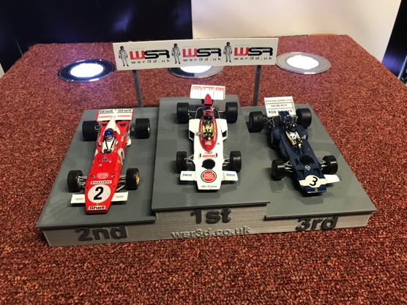
FINAL
So after a long wait and watching all the action, finally Adam Price (Club Member) and John Underwood (Oxford Club again no need of an introduction) get to their race with Pete and Paul.
Adam was in the green lane, which was a brave choice, but he got away well and initially it looked a great decision. But an early tangle for John put him on a back foot leaving Adam to steal away chased by Paul who eventually overtook Adam on lap 26 this then saw a charging John setting fastest lap after lap and eventually overtaking Adam on lap 87 with Pete Chasing hard but just could not get to that podium place with Paul hanging on to take the cup, leaving the order Paul winning John second and Adam bronze medal award.

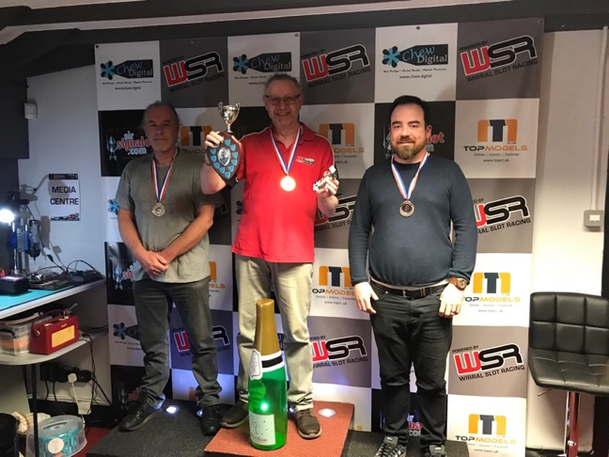
Paul Taylor leaps to the top of the podium after finishing 3rd last year and John unlucky not to have challenged further for the top spot and a good race from Adam for his first podium holding of
the fast-charging Peter C who missed out this year. Paul Taylor getting the honour of his name on the shield for prosperity.

The spirit of the meeting was awarded to Mike Ward for making a great effort to participate in the event, making a visit to Liverpool whilst he and his partner were here, and everyone liked Mike’s smile and positive attitude through out the racing, especially as this was his first time on the track.

Overall, the event ran to time and there were no hick ups, so a big thanks to the organising skills of Peter Wright and Paul Taylor and Club members contributions. As Peter W expressed it was a team effort to make this event happen. The stew was well received and gobbled up by all so that was thanks to Paul Taylor’s culinary skills. The cakes were made by Paul Cooper’s partner so thanks to Joy for that gift. Thanks also for the numerous goodies which were displayed and open for consumption by all, meaning nobody went hungry or was denied a sugar rush this may have been supplied by Mark Brandwood and Paul Cash possibly others so apologies if I missed your name in the contributions. Trophies were supplied and donated by Paul Cooper and the Policar Ferrari for the spirit of the meeting award was donated by Andi Rowlands

Looking forward to next season which we will plan and get pencilled in on the forum calendar as early as possible, so please look out for the booking and updates on the forums and face book.
We would like it to around the same time, first week in April 2025.

